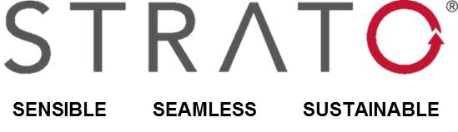
JOB APPLICATION FORM

Please note: *indicates a required field.

Personal Information
First Name* | Last Name*
Email* | Alternative Email*
Mobile Number*

Gender | Marital Status
RSA Citizen? | If you are not an RSA Citizen, please specify

SAP Experience

Primary SAP Module
SAP Module | K Rating
No. of Full Lifecycle Implementations | SAP Experience (Years)
Industry | Industry Experience (Years)

Other SAP Module
SAP Module | K Rating
No. of Full Lifecycle Implementations | SAP Experience (Years)
Industry | Industry Experience (Years)

Other SAP Module
SAP Module | K Rating
No. of Full Lifecycle Implementations | SAP Experience (Years)
Industry | Industry Experience (Years)

Other SAP Module
SAP Module | K Rating
No. of Full Lifecycle Implementations | SAP Experience (Years)
Industry | Industry Experience (Years)

Other SAP Module
SAP Module | K Rating
No. of Full Lifecycle Implementations | SAP Experience (Years)
Industry | Industry Experience (Years)

What Integration Modules are you familiar with? What area of SAP would you like to specialise in?

Requirements
Are you interested in a permanent or contract position? | Are you willing to travel?
Current remuneration? | Required rate or package?
Notice Period | Availability date if contracting  Click or tap to enter a date.
Do you own a SAP work capable Notebook? | Do you own a car?
Do you have a valid driver’s license

Personal Objectives
Please describe your personal objectives, if not already n your CV.

References
Please provide a list of references if applicable.

Additional Information
Please feel free to provide any additional information that might be helpful for our screening / selection.

process

